

Draw it or Lose it

CS 230 Project Software Design
Version 1.3

Table of Contents

CS 230 Project Software Design 1
Table of Contents 2
Document Revision History 2
Executive Summary 3
Requirements 3
Design Constraints 3
System Architecture View 3
Domain Model 5
Evaluation 6
Recommendations 8

Document Revision History

Version | Date | Author | Comments
1.0 | 09/22/2024 | Amaro Terrazas | Initial draft of software design document for The Gaming Room's Draw It or Lose It project.
1.1 | 10/04/2024 | Amaro Terrazas | Added platform evaluation and recommendations for Project Two, including server-side, client-side and development tool considerations.
1.3 | 10/17/2024 | Amaro Terrazas | Added Recommendations section for Project Three, covering Operating Platform, System Architectures, Storage, Memory, Distributed Systems and Security.

Executive Summary

The Gaming Room aims to develop a web-based version of their existing Android-based game, Draw It or Lose It, to support multiple platforms. The game involves teams guessing puzzles based on rendered stock drawings. Expanding this game to multiple platforms requires a web-based architecture, ensuring that the game supports unique game, team, and player names, with only one instance of each entity existing at any given time. Recent updates to the game’s code ensure that names for games, teams, and players are unique within their respective scopes, preventing duplication. This document outlines the design constraints, domain model, and recommendations for the updated architecture.

Requirements

- Multi-Platform Support: The game must be accessible on multiple platforms, including Windows, Mac, Linux, and mobile devices.
- Unique Identifiers: Games, teams, and players must have unique identifiers and names to prevent duplication and ensure clarity during gameplay.
- Team Structure: Support multiple teams, each with multiple players.
- Single Instance: Only one instance of the game can exist in memory at any given time.
- Web-based Architecture: A web-based solution is required, and The Gaming Room needs assistance in setting up the environment for this.

Design Constraints

- Cross-Platform Compatibility: The game must work on multiple platforms, including Windows, Mac, Linux, and mobile devices. This requires the use of cross-platform web technologies such as HTML5, CSS, and JavaScript, ensuring that the game functions properly on different operating systems and browsers.
- Unique Identifiers: To ensure that no duplicate names exist for games, teams, or players, the system must enforce name uniqueness across each scope. This has been implemented by adding checks in the addTeam() and addPlayer() methods to verify that names are unique before allowing a new team or player to be created.
- Performance and Scalability: The game must be able to handle multiple players and teams while maintaining performance. This requires efficient memory and resource management in a distributed system to ensure responsiveness for all users.
- Security: User information, including names and game data, must be securely handled to prevent unauthorized access or breaches. This includes ensuring secure communication between platforms and encrypting sensitive information.

System Architecture View

Note: This section is not required for this project.

UML Class Diagram Description for the Game Application

The UML class diagram for the Draw It or Lose It game application illustrates the relationships between GameService, Game, Team, and Player. The system enforces unique names for games, teams, and players. This is reflected in the addTeam() and addPlayer() methods, which check for name uniqueness before creating new entities. The design follows object-oriented principles, including inheritance, encapsulation, singleton pattern, and composition.

Class Relationships and Inheritance

The Game, Team, and Player classes all inherit from the Entity class. This demonstrates the inheritance principle of object-oriented programming (OOP), allowing each of these classes to reuse common properties like id and name, reducing code duplication and improving maintainability. Each of these classes extends the functionality of Entity to provide behaviors specific to games, teams, and players.
- Game Class: Manages a collection of teams. The class includes a method to add teams (addTeam()) and overrides the toString() method to display game-specific information.
- Team Class: Contains a list of players and provides a method to add players (addPlayer()). Like the Game class, it inherits the id and name attributes from Entity.
- Player Class: Represents individual players within a team and contains methods to manage player-specific information.

The GameService class is responsible for managing all game-related functionality, such as creating new games, managing teams and players, and ensuring the unique identification of each entity through static variables like nextGameId, nextPlayerId, and nextTeamId. GameService is designed as a singleton, meaning only one instance of this class can exist at any given time, ensuring that the game system maintains a single, consistent instance of the game in memory.

Aggregation and Composition

The GameService class maintains a list of Game objects, each Game contains a list of Team objects, and each Team contains a list of Player objects. These relationships are modeled using aggregation, represented in the UML by solid lines with multiplicity (e.g., 0...*), indicating that a game can have zero or more teams, and a team can have zero or more players. This composition ensures a hierarchical relationship between the classes, where a Game is composed of teams, and teams are composed of players.

Object-Oriented Principles in Action

- Inheritance: The Entity base class demonstrates inheritance, allowing the child classes (Game, Team, Player) to share common behaviors and attributes.
- Encapsulation: Each class encapsulates its attributes (id, name, teams, players) and provides controlled access through public methods, ensuring that internal data is not directly exposed.
- Singleton Pattern: The GameService class applies the singleton design pattern, ensuring only one instance of the service exists at any time, preventing multiple concurrent instances of games in memory.
- Composition and Aggregation: The relationships between GameService, Game, Team, and Player classes demonstrate composition and aggregation, modeling the hierarchical structure of the game system.

Domain Model

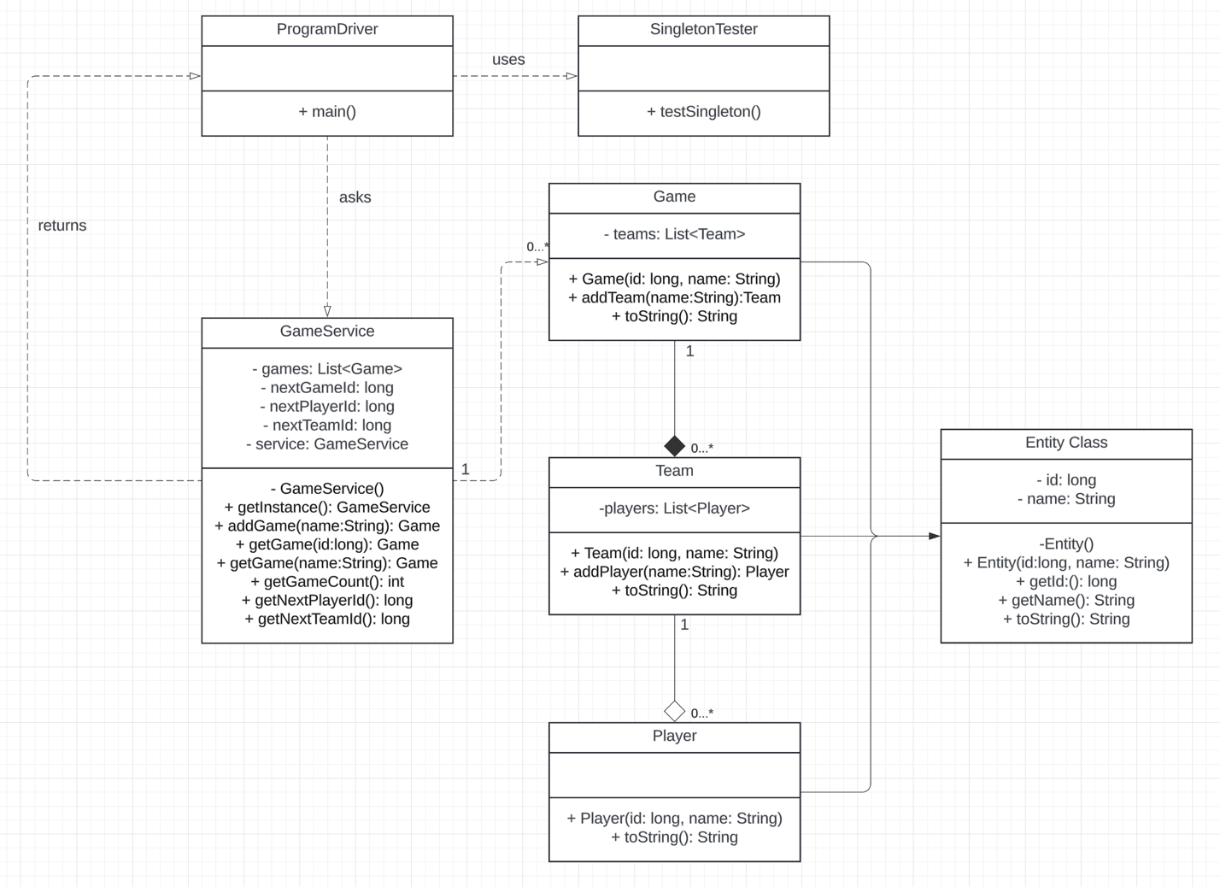

Evaluation

Using your experience to evaluate the characteristics, advantages, and weaknesses of each operating platform (Linux, Mac, and Windows) as well as mobile devices, consider the requirements outlined below and articulate your findings for each. As you complete the table, keep in mind your client’s requirements and look at the situation holistically, as it all has to work together.

In each cell, remove the bracketed prompt and write your own paragraph response covering the indicated information.

Development Requirements | Mac | Linux | Windows | Mobile Devices
Server Side | Mac provides stability and good performance for web hosting but lacks the flexibility of Linux. While it supports scalable tools like Apache Tomcat or Nginx, its higher cost and licensing fees can be a concern. Additionally, some server tools may not be as readily available compared to Linux. | Linux is the most widely used server-side operating system due to its open-source nature, high level of security, flexibility, and scalability. It supports a wide range of tools like Apache,  Nginx, Docker, and Kubernetes. Linux is cost-effective and ideal for scaling up to support thousands of players. Cloud platforms like AWS and  GoogleCloud provide excellent Linux integration. | Windows provides ease of use and strong integration with enterprise environments through IIS and  .NET Core. However, it is less common for web server hosting compared to Linux, and licensing costs (Windows Server and associated tools) can be high, though it offers good support for Azure. | Hosting a web server on mobile devices is impractical due to limited resources and performance constraints. Mobile devices will primarily function as clients, connecting to remote servers that host the game. Servers can be hosted on AWS Lambda or Google Cloud Functions, which can scale dynamically based on traffic.
Client Side | Developing for Mac clients requires expertise in macOS and iOS development, often using Xcode, Swift, and Objective-C. Macs are commonly used in creative industries, which makes targeting macOS users an essential consideration for graphical and design-focused applications. Browser compatibility with Safari also requires additional testing. | Linux clients are often technically proficient, so developing for Linux involves ensuring compatibility with various distributions (Ubuntu, Fedora, etc.). Browser support includes Firefox and Chromium, but you’ll need to test compatibility across different package managers and environments. Open-source libraries help keep costs low. | Windows clients are the most widely used across various industries, making it necessary to focus on browser compatibility with Edge, Chrome, and Firefox. Developing for Windows is straightforward, though licensing costs can be high. Tools like Visual Studio and .NET are widely used. | Mobile development requires the use of React Native or Flutter to ensure compatibility with both iOS and Android. Cross-platform tools allow you to deliver apps efficiently, while Appium or  BrowserStack can be used to test browser compatibility and responsiveness on mobile devices.
Development Tools | Xcode, Swift, and Objective-C are standard tools for macOS and iOS development. Licensing costs for development tools are present, and specialized skills are required. Testing across Safari and different screen resolutions is crucial to ensure compatibility. | Linux supports a wide range of open-source development tools like Eclipse, Vim, GCC, and Docker, which allow for cost-effective and flexible development. Linux is ideal for cross-platform web development using technologies such as JavaScript, Node.js, and Python. | Windows development tools include Visual Studio, .NET Core, and Microsoft SQL Server. These tools provide excellent support for enterprise applications, but licensing costs can be significant. Windows offers easy integration with Azure DevOps for continuous deployment. | Development for mobile devices requires cross-platform frameworks like React Native, Flutter, or Ionic. These tools allow for efficient development of mobile and web apps. Testing tools such as Appium and Selenium help ensure the app works across different devices and screen sizes.

Recommendations

Analyze the characteristics of and techniques specific to various systems architectures and make a recommendation to The Gaming Room. Specifically, address the following:

- Operating Platform: According to the evaluation, Linux is the optimal platform for The Gaming Room’s web-based application. Its open-source characteristics, adaptability, and comprehensive toolchain (including support for Docker, Kubernetes, and Nginx) render it optimal for extensive deployment. Additionally, the cost-efficiency of Linux hosting platforms and their robust support for cloud integration (AWS, Google Cloud) provide a distinct advantage for server-side operations. Cloud-based hosting enables The Gaming Room to efficiently scale its operations, accommodating thousands of concurrent players.

- Operating Systems Architectures: Linux-based systems are strongly recommended for their exceptional support of server-side settings, with robust process isolation and advanced virtual memory management features. These attributes are crucial for guaranteeing the game's scalability and performance while accommodating thousands of concurrent users. Linux has extensive customization capabilities, facilitating improved resource management to accommodate many game instances, hence ensuring efficient utilization of memory and processing power across servers.

- Storage Management: I recommend adopting a cloud-based storage solution such as AWS S3 or Google Cloud Storage for storage management. These systems provide elastic scalability, minimal latency, and data redundancy, guaranteeing the constant availability of user and game data. Both alternatives offer comprehensive security measures, including data encryption both at rest and in transit, and adhere to industry standards for secure data storage. Moreover, cloud-based storage enables The Gaming Room to augment storage capacity dynamically in response to rising user demand, eliminating the necessity for physical upgrades.

- Memory Management: Linux provides efficient memory management strategies that are essential for sustaining the game's performance. Methods such as virtual memory and process isolation guarantee the game's efficient operation, even with numerous teams and players connected simultaneously. This memory management feature will enable the game to sustain low latency and rapid response times, which are crucial for an uninterrupted user experience. Furthermore, the Linux kernel facilitates dynamic memory allocation, ensuring efficient resource utilization under heavy loads.

- Distributed Systems and Networks: The web-based game must utilize a microservices architecture to decompose the program into smaller, independently deployable components. Employing protocols such as HTTP and WebSockets will enhance communication between the client and the server. Furthermore, implementing load balancing techniques across various Linux servers and utilizing Kubernetes for container orchestration can provide high availability and scalability. A failover system must be established to reduce downtime during server failures, hence assuring minimal inconvenience for users in the event of hardware or network outages.

- Security: Security is of utmost importance. User data and game-related information must be protected with SSL/TLS during transmission and with AES-256 encryption for data stored in the cloud. Utilize OAuth 2.0 for secure authentication and role-based access control (RBAC) to restrict access to sensitive information. Routine security audits must be performed, and intrusion detection systems (such as Snort or OSSEC) should be employed to watch for anomalous activities or potential breaches. Deploying logging and monitoring tools will facilitate the real-time detection of vulnerabilities, thereby safeguarding The Gaming Room against emerging threats.

